Experiment No. 09
Create a Scrum Project in Jira

Aim
To create a Scrum project in Jira, add backlog items, prioritize them, create a one-week sprint, move the backlog items into the sprint, and start the sprint to simulate the Scrum development process.

Software Requirements
Software | Version
Jira Cloud | Web Application
Web Browser | Google Chrome / Microsoft Edge
Internet Connection | Required

Theory
Scrum is an agile framework used in software development to manage and complete complex projects through short, time-boxed iterations known as sprints. It emphasizes iterative progress, collaboration, and continuous feedback among team members.
A Product Backlog is a prioritized list of features, tasks, or requirements that need to be completed during the course of a project. A Sprint is a fixed time period, typically one to four weeks, during which a selected set of backlog items is developed and delivered.
In Software Engineering, Jira supports the Scrum framework by allowing teams to create backlogs, plan sprints, and track task progress on a Sprint Board. This helps teams deliver working software incrementally while maintaining flexibility to adapt to changing requirements.

Procedure
Step 1: Create a Scrum Project
1. Log in to Jira Cloud.
2. Click Create Space.
3. Select Software Development.
4. Choose the Scrum template.
Enter the following project details:
Field | Value
Project Name | Online Shopping System
Management Type | Company-managed
Project Key | OSS

Click Create.
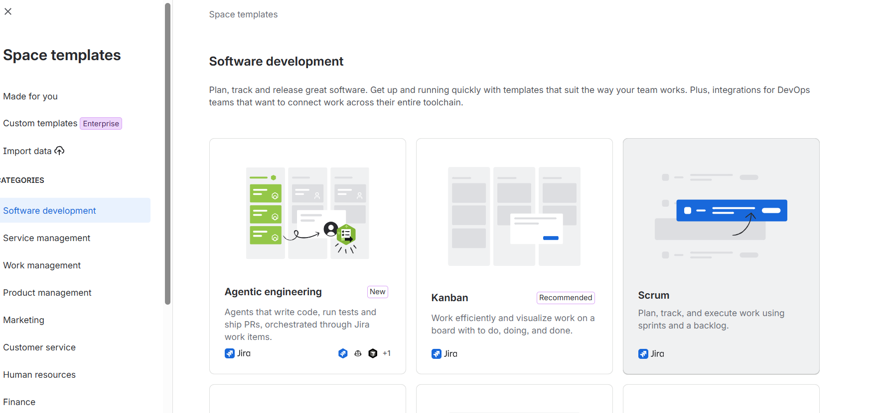
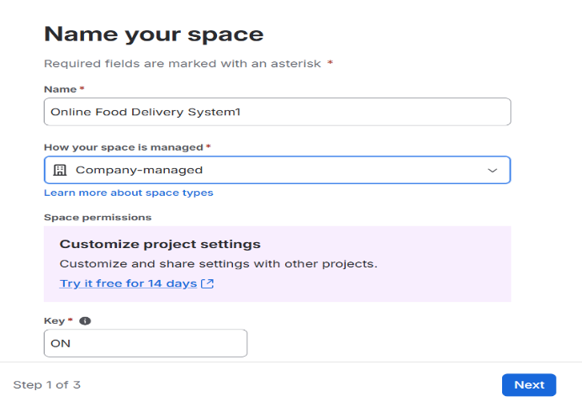

Figure 1. Creating a Scrum Project.
Step 2: Create Product Backlog
Open the Backlog section and create the following backlog items.
Priority | Backlog Item
High | Create User Registration Page
High | Develop Login API
Medium | Design Product Listing Page
Medium | Implement Shopping Cart
Low | Test Checkout Module
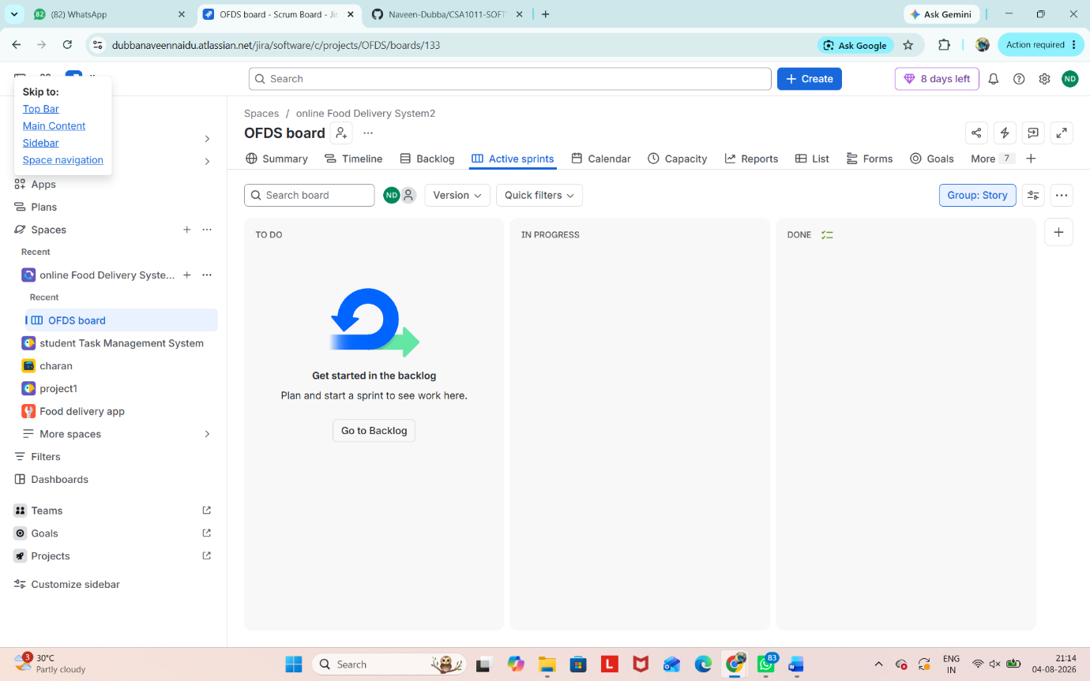
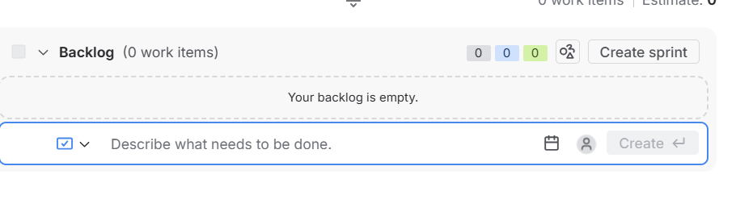

Figure 2. Creating Product Backlog Items.
Step 3: Prioritize the Backlog
Arrange the backlog in the following order:
1. Create User Registration Page
2. Develop Login API
3. Design Product Listing Page
4. Implement Shopping Cart
5. Test Checkout Module
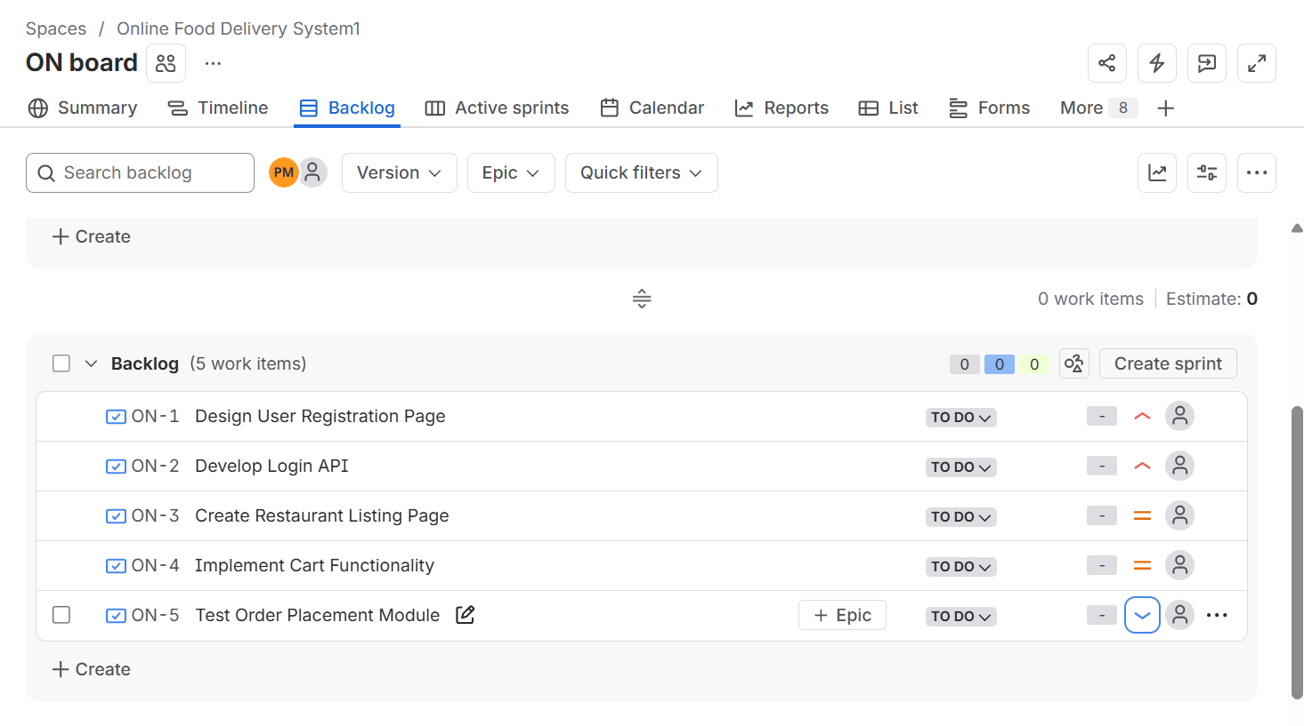
Figure 3. Prioritizing the Backlog.
Step 4: Create a Sprint
Click Create Sprint.
Enter the following details:
Field | Value
Sprint Name | Sprint 1
Duration | 1 Week

Save the sprint.
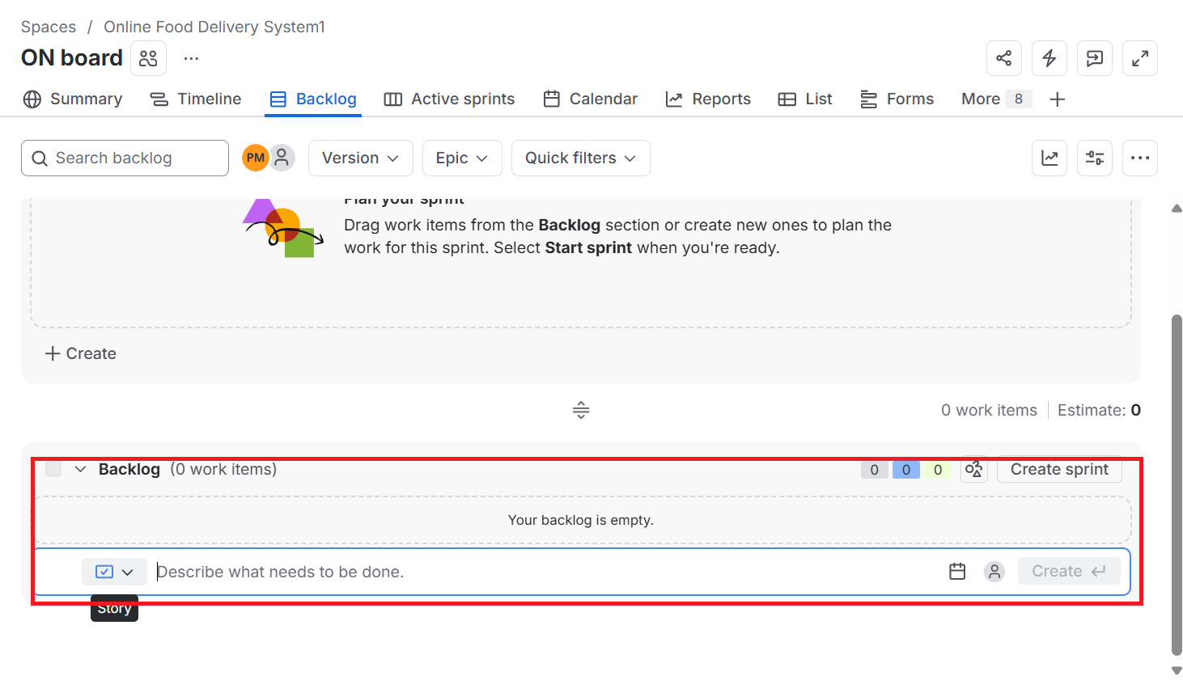
Figure 4. Creating Sprint 1.
Step 5: Add Backlog Items to Sprint
Move all five backlog items into Sprint 1.
Sprint Backlog:
- Create User Registration Page
- Develop Login API
- Design Product Listing Page
- Implement Shopping Cart
- Test Checkout Module
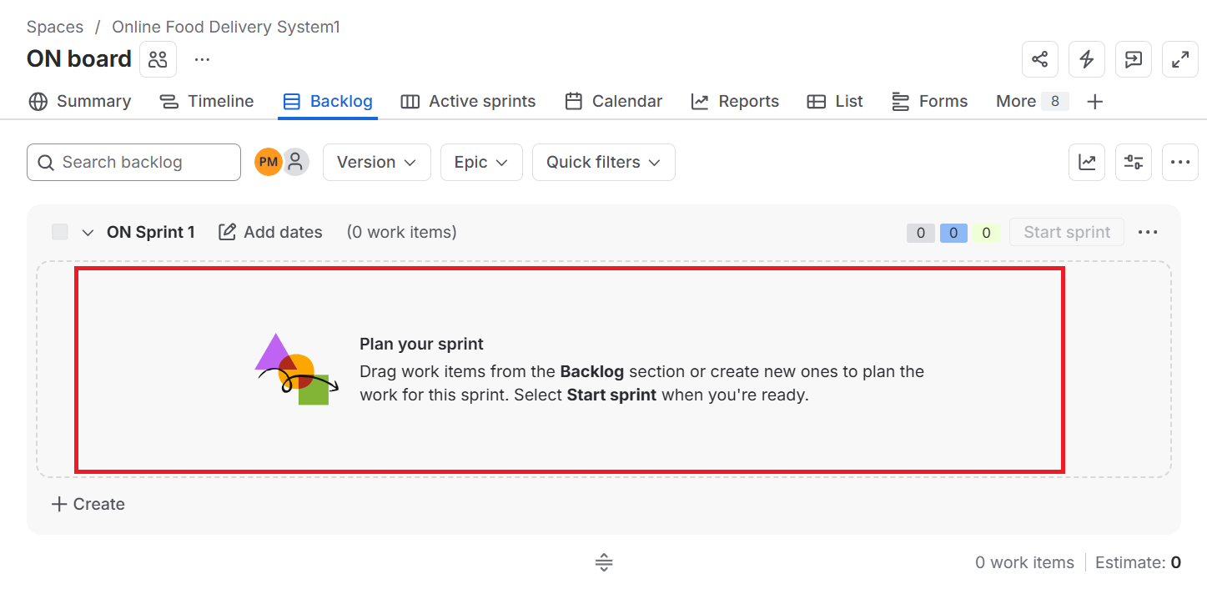
Figure 5. Adding Backlog Items to Sprint.
Step 6: Start the Sprint
1. Click Start Sprint.
2. Confirm the sprint duration is 1 Week.
3. Click Start.
The Sprint Board will display all tasks under the To Do column.
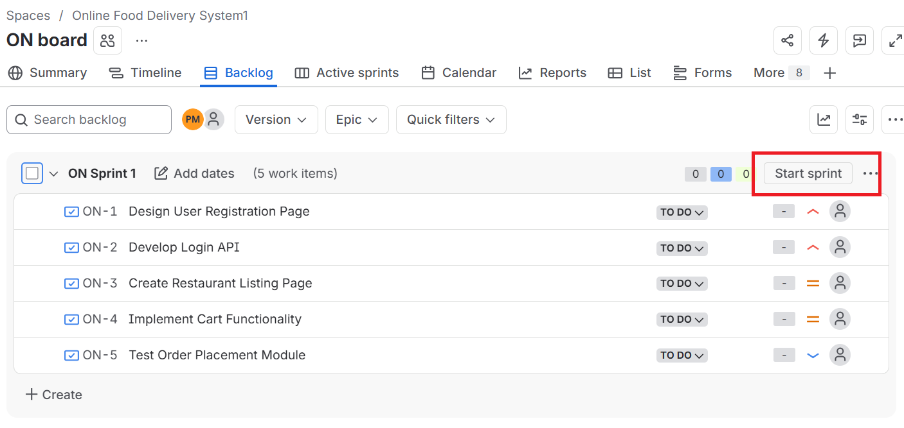
Figure 6. Starting the Sprint.
Step 7: Update Sprint Progress
Move the tasks to simulate development.
Task | Status
Create User Registration Page | Done
Develop Login API | Done
Design Product Listing Page | In Progress
Implement Shopping Cart | To Do
Test Checkout Module | To Do

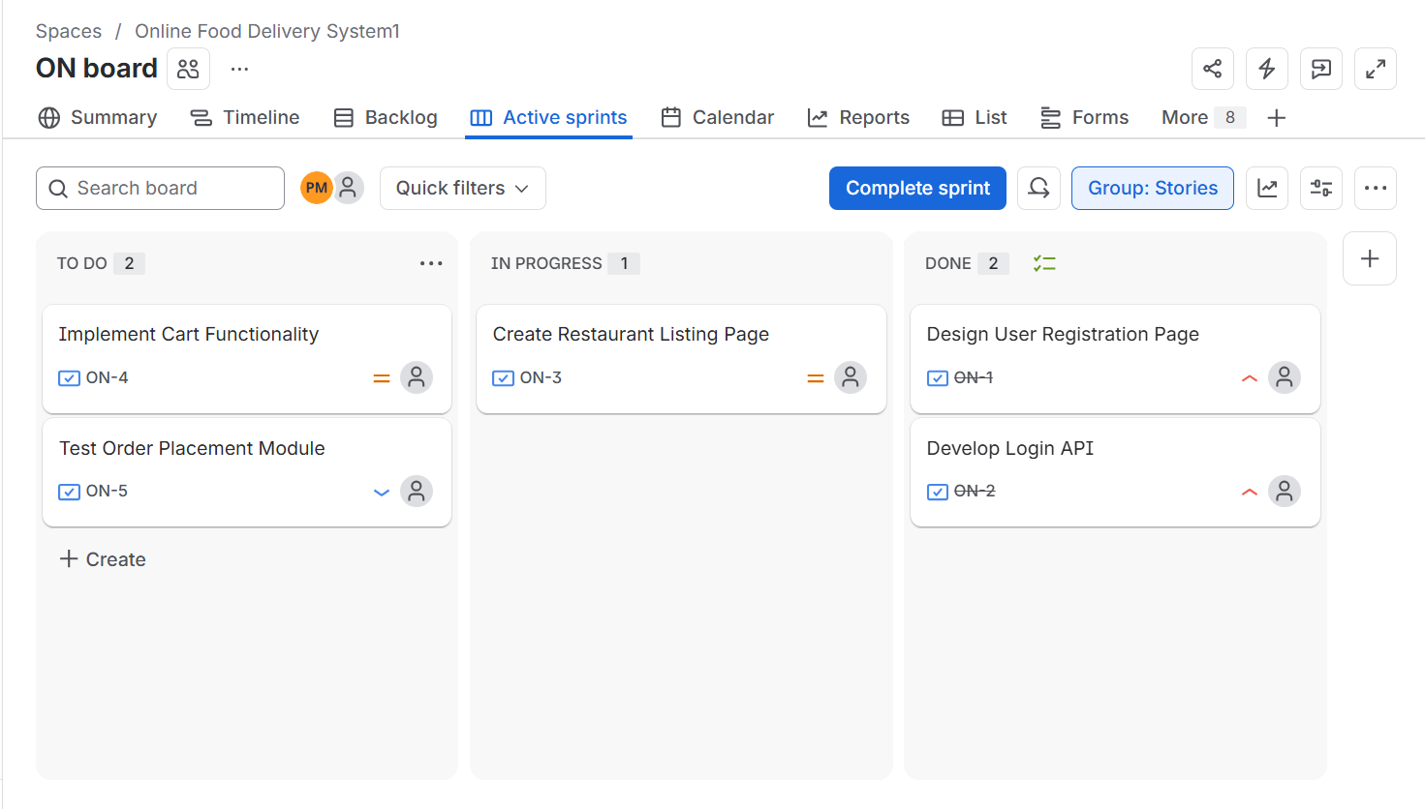
Figure 7. Updating Sprint Progress.
Step 8: Sprint Completion
The Sprint Board should display the following status:
Done
- Create User Registration Page
- Develop Login API
In Progress
- Design Product Listing Page
To Do
- Implement Shopping Cart
- Test Checkout Module
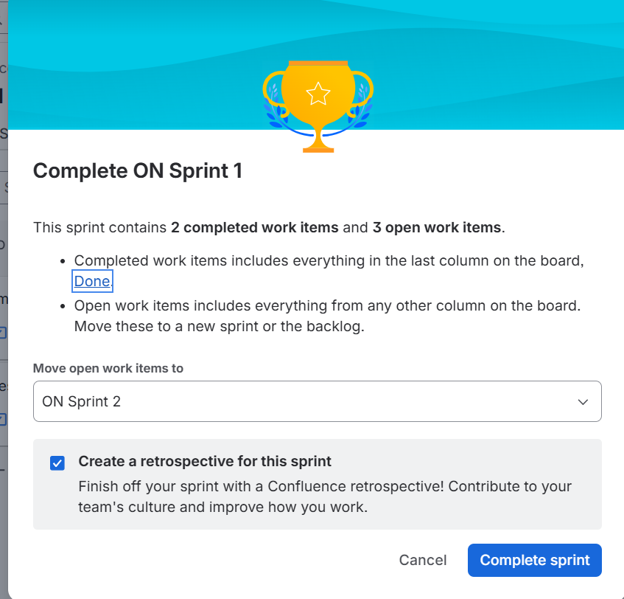
Figure 8. Sprint Completion Status.

Observation
Sprint Name | Total Tasks | Completed | In Progress | Pending
Sprint 1 | 5 | 2 | 1 | 2

Result
A Scrum project named Online Shopping System was successfully created in Jira. Five backlog items were added and prioritized, a one-week sprint was created, backlog items were assigned to the sprint, and the sprint was started successfully. The Sprint Board effectively demonstrated task progression using the Scrum workflow.

